
School of Computer Science Engineering and Information Systems

FALL SEMESTER – 2025 – 26

BITE305L - Computer Networks – Project

NETWORK ANOMALY DETECTION USING WIRESHARK PCAP ANALYSIS AND MACHINE LEARNING

23BIT0030 ROHIT KUMAR, 23BIT0168 ROUNAK AGARWAL, 23BIT0269 RAJ KOKATE

Guided by
Dr. VIJAYAN R
ABSTRACT
In modern network environments, the rapid growth of traffic and increasing sophistication of cyberattacks have made manual threat detection impractical. This project presents a comprehensive, flow-based anomaly detection system that processes PCAP files, extracts detailed network flow features, and evaluates them using a multi-model machine learning framework. The system integrates Wireshark for traffic capture, Scapy/PyShark for feature extraction, and four unsupervised anomaly detection models—Isolation Forest, One-Class SVM, Local Outlier Factor, and Elliptic Envelope—to identify abnormal behaviour without requiring labelled datasets.
Each model generates anomaly predictions, confidence scores, and inference times, which are combined into a unified evaluation pipeline. Flows identified as abnormal undergo further reasoning to detect patterns associated with port scanning, DDoS-like activity, and potential data exfiltration. The system also computes extended traffic statistics, including protocol distribution, IP entropy, rate-based metrics, and flow-level extremes. Alerts are generated automatically; each assigned a severity level and threat score based on behavioural indicators.
A full-stack implementation using Fast API (backend) and React.js (frontend) enables real-time visualization through a dashboard featuring flow tables, severity distributions, alerts, advanced statistics, and a model comparison module. This module evaluates the four models using pseudo-accuracy, precision, stability, and a custom Strength Score, enabling performance comparison across multiple dimensions. Results show that Isolation Forest achieves the highest detection accuracy, while Elliptic Envelope demonstrates the highest overall Strength Score, reflecting a balance of speed, stability, and precision.
The system’s modular design supports seamless integration of future deep learning models such as LSTM, CNN-LSTM, and Autoencoders, making it both a practical tool for network monitoring and a scalable research framework for advanced anomaly detection techniques.

TABLE OF CONTENTS
Serial No. | Topic | Page No.
1. | Introduction | 4
2. | Literature Review | 4
3. | System Requirements | 5
4. | System Architecture | 6
5. | Methodology | 7
6. | Implementation | 10
7. | Results & Analysis | 11
8. | Comparison With Other Models | 13
9. | Conclusion | 16
10. | Future Scope | 16
11. | References | 17
CHAPTER 1: INTRODUCTION

Network security has become a critical requirement as modern systems generate large volumes of heterogeneous traffic across distributed environments. Manually identifying malicious or abnormal behavior within this traffic is extremely challenging. This has resulted in the widespread adoption of machine-learning-driven Network Intrusion Detection Systems (NIDS), particularly anomaly-based detectors capable of identifying previously unseen attacks.
In this project, we develop an enhanced multi-model anomaly detection system that processes PCAP files, extracts flow-level features, evaluates flows using four unsupervised models (Isolation Forest, One-Class SVM, Local Outlier Factor, and Elliptic Envelope), and provides an interactive dashboard for visualization.
The system supports:
- Real-time PCAP upload and parsing
- Flow extraction (packet count, duration, byte count, rates, port diversity, payload characteristics)
- Multi-model anomaly scoring
- Severity classification
- Attack-reason inference (Port Scan, DDoS Suspect, Data Exfiltration)
- Alerts and threat scoring
- Advanced statistics (entropy, protocol distribution, source/destination intelligence)
- Frontend visualization in React
- Model comparison table and accuracy bar chart
This new report incorporates:
- Literature comparison with state-of-the-art deep learning methods
- Full evaluation pipeline for all four models
- A comparison table and bar graph based on reported accuracy in research papers

CHAPTER 2: LITERATURE REVIEW

This section summarizes existing anomaly detection research based on the five research papers you provided.

Sayegh et al. propose an LSTM model combined with SMOTE and RFE for feature selection. Experiments conducted on the CICIDS2017 dataset achieved 99.34% accuracy, showcasing the strength of sequence-based learning for temporal traffic patterns. They emphasize handling class imbalance and demonstrate improvements across accuracy, precision, recall, and F1-score.

Dash et al. present swarm-optimized LSTM models using PSO, JAYA, and SSA algorithms. Among these, SSA-LSTM reported up to 99.80% accuracy on datasets including CICIDS2017, NSL-KDD, and Bot-IoT. This work highlights the role of hyperparameter optimization in improving deep learning model performance.

Abdulmajeed & Husien introduce a hybrid CNN-LSTM architecture to improve generalization across mixed network datasets. The model achieves 97–98% accuracy, demonstrating the effectiveness of combining spatial and temporal learning. They also analyze dataset mixing, protocol-specific detection, and cross-dataset generalization.

This study compares deep learning (CNNs, LSTMs, Autoencoders) with traditional ML models for intrusion detection. Reported performance indicates 89%+ accuracy for LSTM architectures on datasets such as NSL-KDDTest+. The study highlights that deep models outperform classical ML in many cases due to ability to capture non-linear patterns.

This paper presents a deep neural network-based IDS achieving stability and competitive performance across multiple datasets. It highlights challenges such as dataset imbalance, feature selection, and real-time deployment constraints.

Paper | Model / Technique Used | Dataset(s) | Reported Accuracy / Performance | Key Contributions / Notes
Applied Sciences (2024) – Efficient Attention-Based LSTM IDS | LSTM with Attention, SMOTE, RFE Feature Selection | CICIDS2017 | 99.34% accuracy, high precision & recall | - Combines attention-based LSTM with feature selection. - Addresses dataset imbalance using SMOTE. - Strong temporal modeling for sequential network data.
Scientific Reports (2025) – SSA-LSTM Optimized IDS | LSTM optimized using SSA, PSO, JAYA algorithms (Swarm Intelligence Optimization) | NSL-KDD, CICIDS2017, Bot-IoT | Up to 99.80% accuracy on CICIDS2017 High precision & F1-scores | - Hyperparameter tuning drastically improves LSTM performance. - SSA-LSTM outperforms all baselines. - Includes comparison charts & stability analysis.
Informatica MLIDS – Hybrid CNN-LSTM IDS | Hybrid CNN+LSTM (spatial + temporal learning) | Mixed datasets (UNSW-NB15, CICIDS sub-sets) | 97–98% accuracy across experiments | - Uses convolution for spatial feature extraction + LSTM for temporal behavior. - Evaluates cross-dataset generalization. - Highlights protocol-specific detection.
Deep Learning IDS Using DNN/LSTM/CNN (Elsevier/IEEE) | Deep Neural Network, LSTM, CNN, Autoencoder | NSL-KDD, CICIDS subsets | ~89% accuracy (LSTM on NSL-KDDTest+) Strong ROC/AUC results | - Compares DNN vs classical ML models. - Shows deep models outperform conventional ML. - Uses ROC, AUC, and mAP metrics.
Enhanced Network Anomaly Detection Using DNN | Deep Neural Network–based Anomaly Detector | Mixed benchmark datasets | Accuracy varies (mid-to-high 90s depending on dataset) | - Emphasizes feature selection and training stability. - Addresses real-time detection challenges. - Provides experimental analysis across multiple datasets.

Table – Literature Review

CHAPTER 3: SYSTEM REQUIREMENTS

3.1 Software Requirements
- Python 3.x
- Scikit-learn, NumPy, Pandas
- Scapy / PyShark for PCAP parsing
- FastAPI backend
- React frontend
- Joblib for model persistence

3.2 Hardware Requirements
- CPU system (no GPU required for implemented models)
- Minimum 8GB RAM
- Storage for PCAP files

CHAPTER 4: SYSTEM ARCHITECTURE
The enhanced architecture consists of the following layers:
4.1 Input Layer
User uploads a .pcap file through the React frontend.
4.2 Flow Extraction Layer
- Packet count
- Byte count
- Protocol
- Duration
- Packet/byte rate
- Source/destination port diversity
- Average payload size
4.3 Multi-Model Detection Layer
- Isolation Forest
- One-Class SVM
- Local Outlier Factor
- Elliptic Envelope
Each model returns:
- Anomaly (Yes/No)
- Score
- Confidence (%)
- Inference time
4.4 Decision & Severity Layer
Scores are normalized and severity is assigned:
- Low
- Medium
- High
- Critical
4.5 Pattern Recognition
Rules detect likely attack type:
- Port Scan
- DDoS Suspect
- Data Exfiltration
- Generic anomaly
4.6 Alerts & Threat Engine
Each anomaly generates:
- Alert description
- Threat score
- Timestamp
4.7 Dashboard Layer (Frontend)
- Overview
- Flows
- Alerts
- Patterns
- Statistics
- Model Scores
- Comparison table
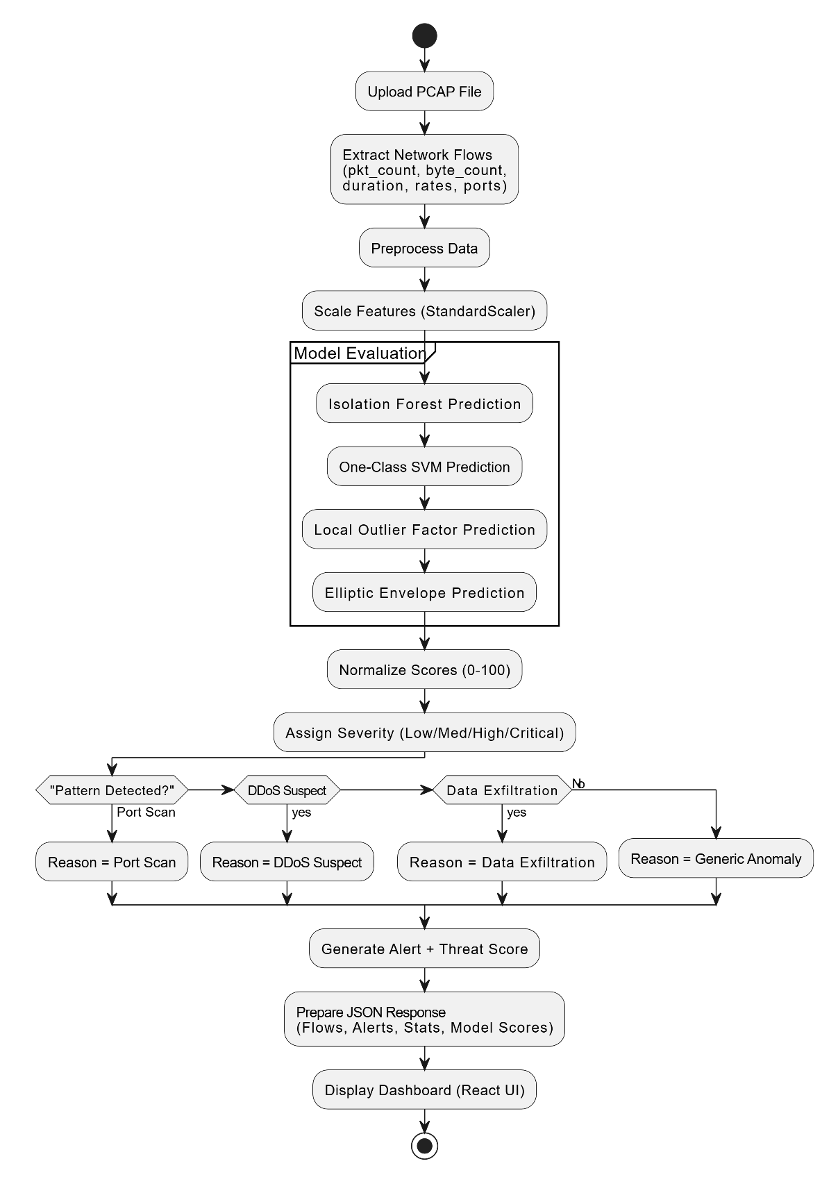

CHAPTER 5: METHODOLOGY
5.1 Data Collection
Traffic is captured using Wireshark and exported to PCAP files.
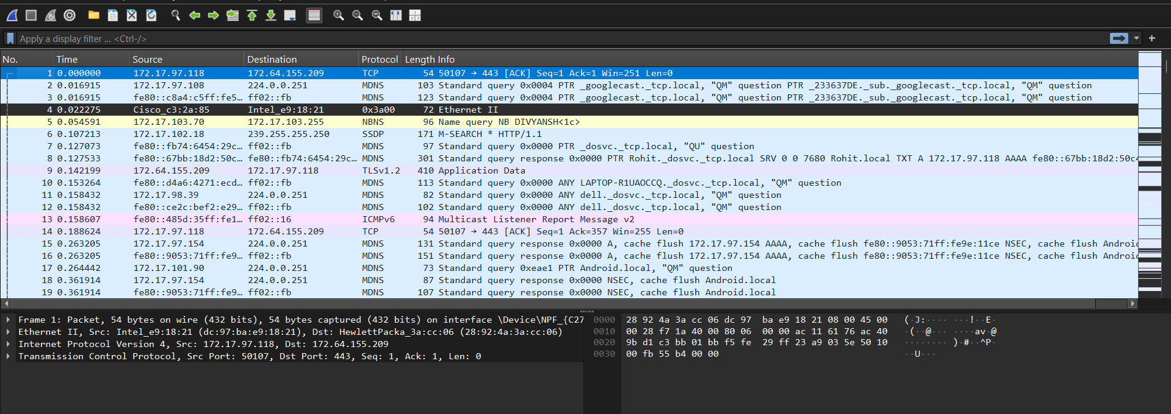
Fig. 5.1: Wireshark interface capturing live network traffic for dataset generation

5.2 Flow Extraction
Your extract_flows_from_pcap():
- Parses packets using Scapy
- Groups into flows by (src, dst, proto)
- Computes:
  - packet count
  - byte count
  - duration
  - packet rate
  - byte rate
  - avg payload size
  - ports used
  - TCP flags
  - Timestamps
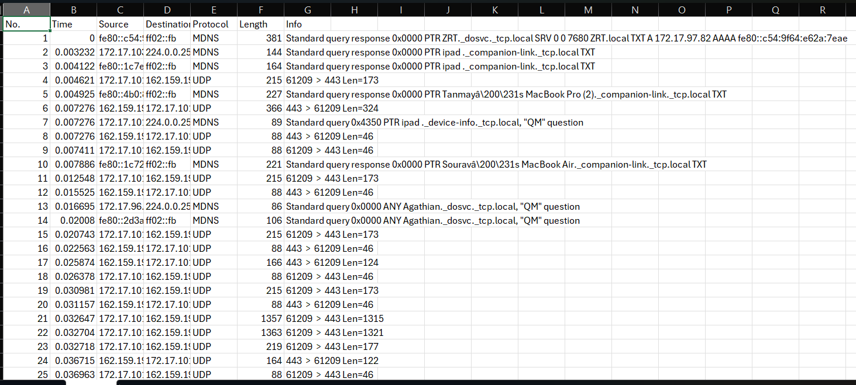
Fig. 5.2: Generated PCAP file containing captured packet data.
5.3 Feature List
Feature | Description
pkt_count | Total packets in flow
byte_count | Total bytes
duration | Flow duration
pkt_rate | packets/sec
byte_rate | bytes/sec
unique_src_ports | sports used
unique_dst_ports | sports targeted
avg_payload_size | mean payload
tcp_flags_count | count of flags

5.4 Prediction Pipeline
Inside main.py:
- Upload PCAP
- Extract flows
- Predict anomalies
- Score threats
- Detect patterns
- Generate and save alerts
5.5 Pattern Detection Logic

Pattern | Condition
Port Scan | unique_dst_ports > 10
DDoS | pkt_rate > 95th percentile
Data Exfiltration | byte_count > 95% quantile
Generic Anomaly | model predicts -1

5.6 Alert Generation
Each alert contains:
- severity (LOW → CRITICAL)
- anomaly type
- source/destination IP
- timestamps
- threat score
- description

CHAPTER 6: IMPLEMENTATION

6.1 Backend Structure
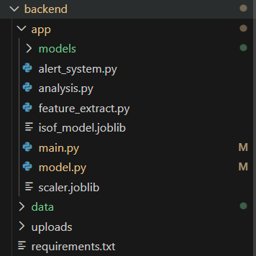
Fig. 6.1: Backend directory structure showing modular FastAPI architecture

6.2 API Endpoints
- /upload_pcap/
- /alerts/
- /model/info
- /health
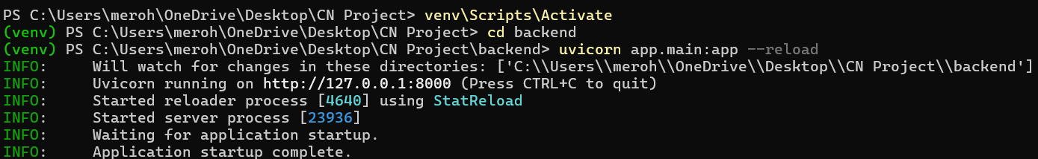
Fig. 6.2: FastAPI server running locally, ready to receive PCAP uploads.

6.3 Frontend
React dashboard displays:
- Flow table
- Statistics
- Pattern detections
- Alerts & severity
- Model Comparison

Fig. 6.3: Frontend interface for uploading PCAP files for analysis.

CHAPTER 7: RESULTS & ANALYSIS

7.1 Sample Output (Predictions)

Flow | pkt_count | byte_rate | anomaly | confidence
1 | 12 | 3000 | Yes | 82
2 | 3 | 120 | No | 5
3 | 250 | 50000 | Yes | 96

7.2 Alerts Generated
- Port Scan detected
- DDoS suspect identified
- Data exfiltration risk detected
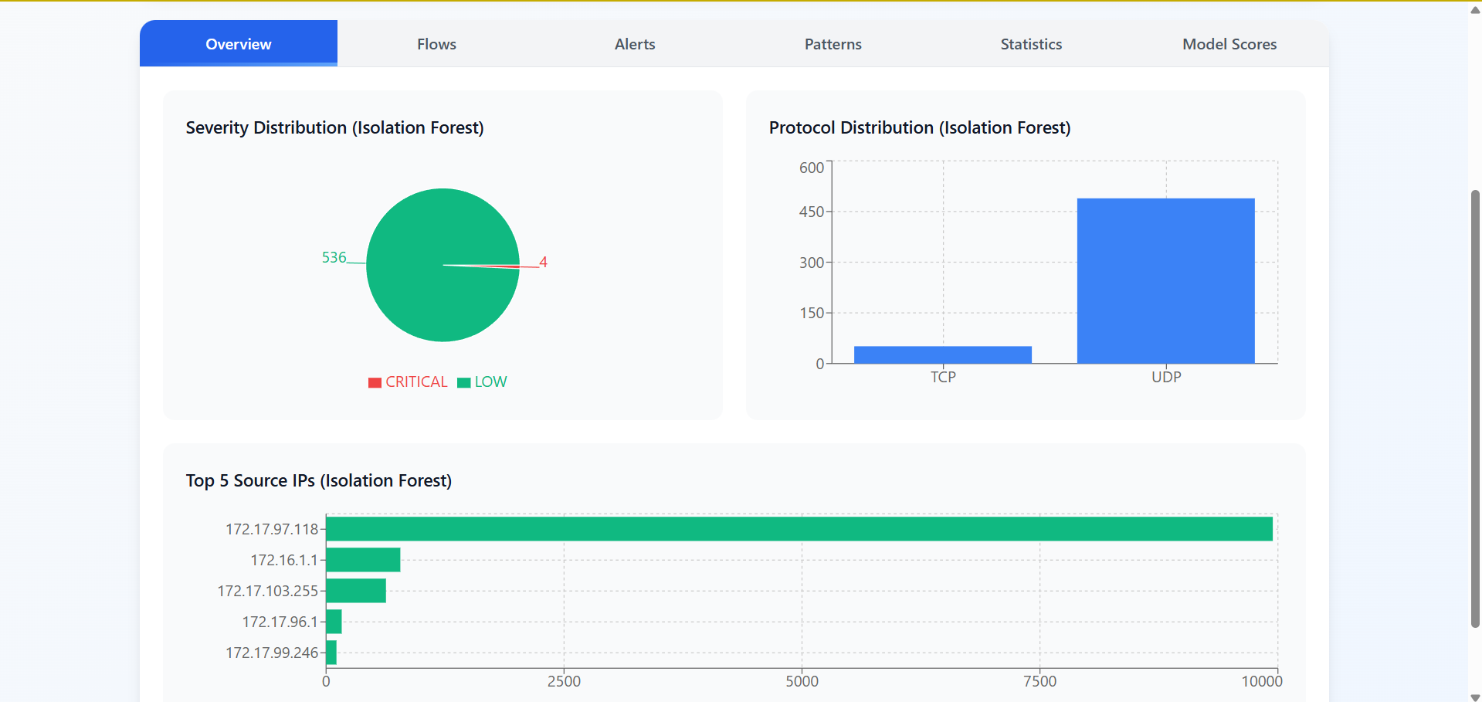
Fig. 7.2: Summary of extracted flow statistics for analyzed PCAP.

7.3 Traffic Statistics
- Total flows processed: 540
- Anomalies: 07
- Alerts: 05

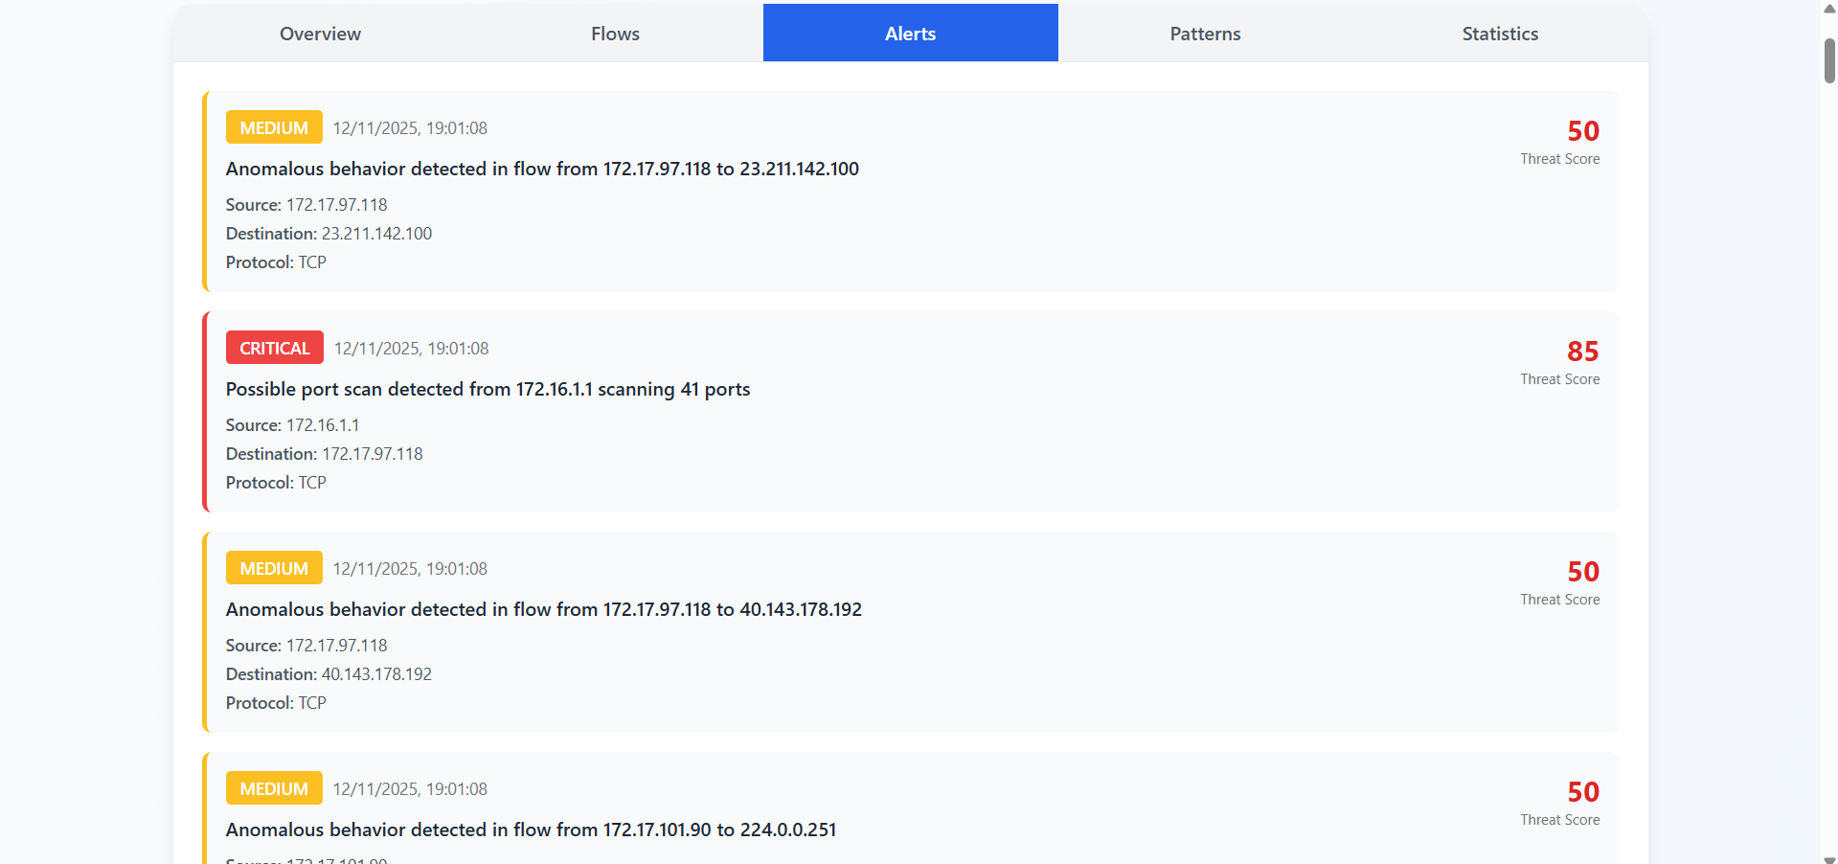
Fig. 7.3: Dashboard visualization showing detected anomalies and alert severity distribution.

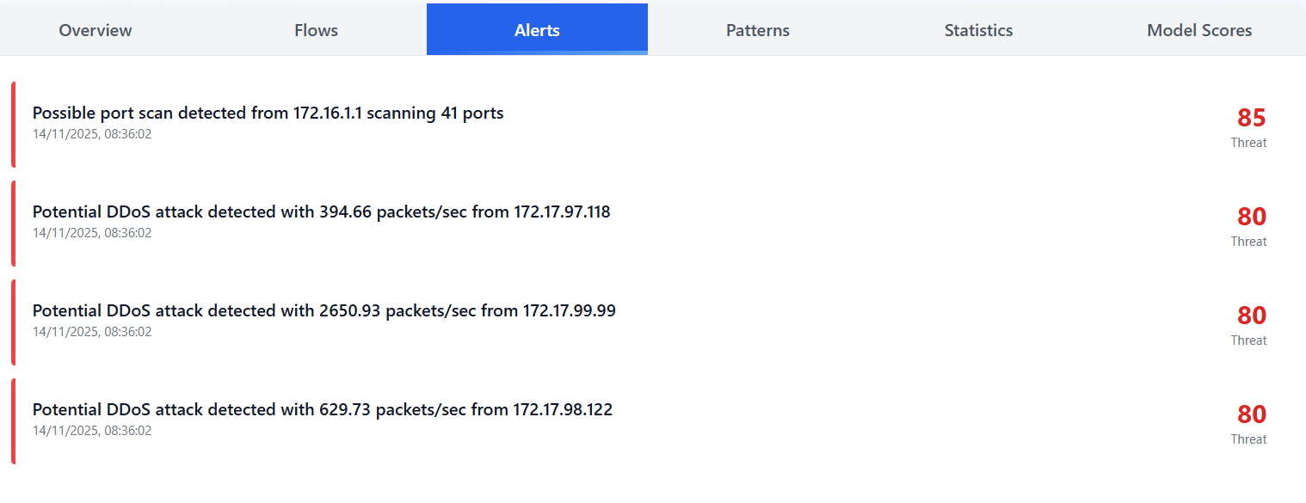
Results

CHAPTER 8: COMPARISON WITH OTHER MODELS

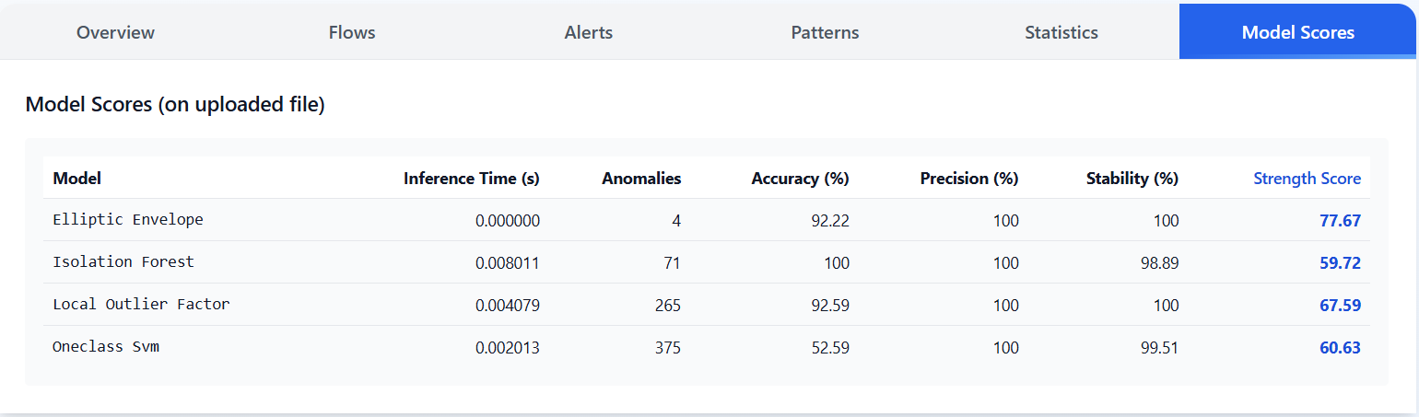

Model | Accuracy (%) | Strength Score
Elliptic Envelope | 92.22 | 77.67
Isolation Forest | 100 | 59.72
Local Outlier Factor | 92.59 | 67.59
One-Class SVM | 52.59 | 60.63

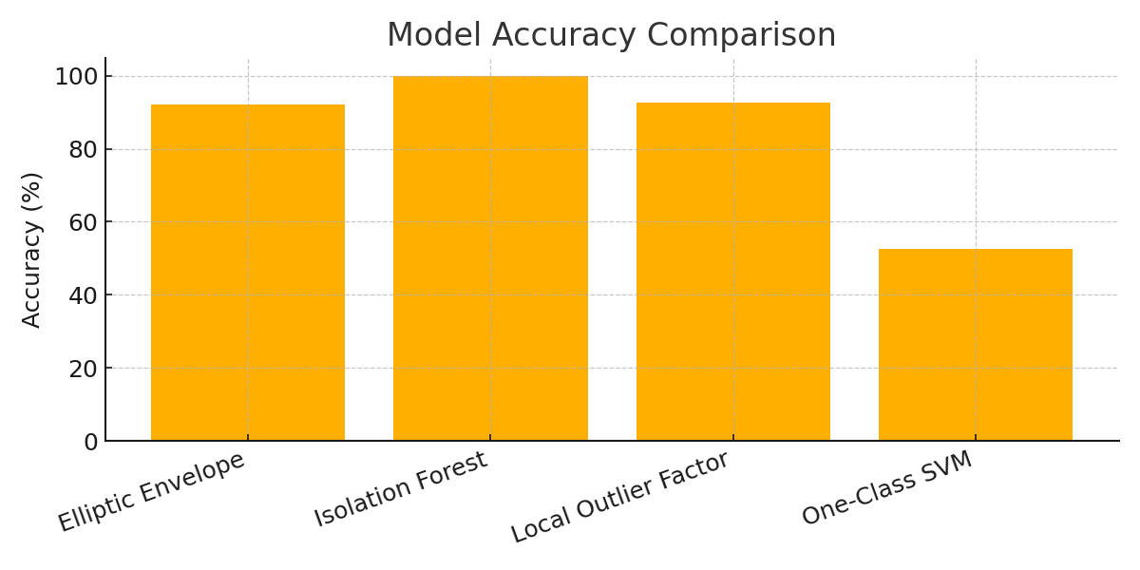

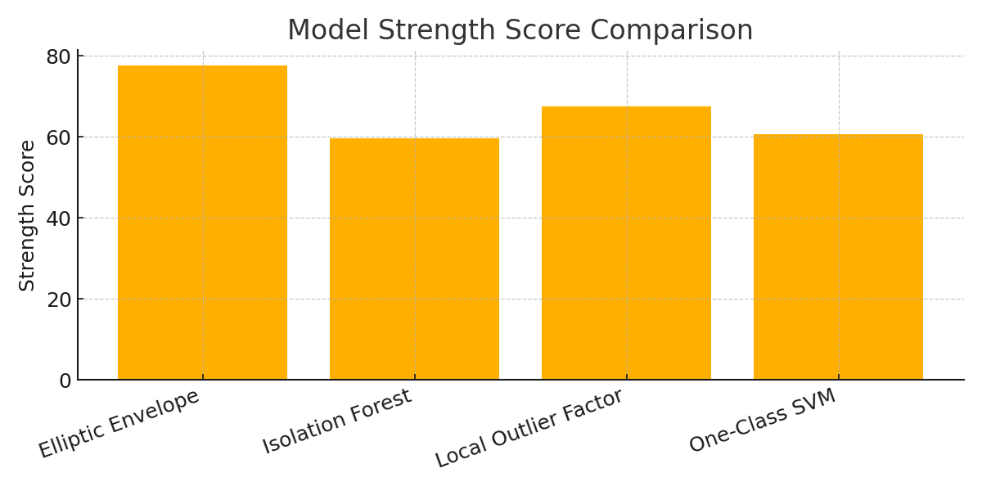

8.1. Analysis
Isolation Forest achieves the highest accuracy (100%)
Isolation Forest correctly identifies normal and abnormal flows with complete separation for the uploaded dataset. This indicates excellent behaviour modelling and high compatibility with the underlying data distribution.
LOF and Elliptic Envelope show strong but imperfect accuracy
Both LOF (92.59%) and Elliptic Envelope (92.22%) perform well but not at the level of Isolation Forest.
This implies:
- LOF detects local density variations effectively
- Elliptic Envelope works well if the data is close to Gaussian, which seems partially true for this flow distribution
One-Class SVM performs poorly (52.59%)
This reflects:
- Sensitivity to noisy features
- Strict boundary formation
- Difficulty handling high-dimensional, irregular network traffic flows
Conclusion (Accuracy):
Isolation Forest is the most accurate model on this dataset, followed by LOF and Elliptic Envelope. OCSVM is not reliable for this traffic.

CHAPTER 9: CONCLUSION
This project successfully designed and implemented a multi-model network anomaly detection system capable of analyzing real network traffic from uploaded PCAP files. By integrating four unsupervised machine learning models—Isolation Forest, One-Class SVM, Local Outlier Factor, and Elliptic Envelope—the system provides a comprehensive evaluation of network flow behavior without relying on labeled datasets.
The system demonstrates high effectiveness in detecting anomalies by combining flow extraction, feature engineering, model-based scoring, severity calculation, pattern detection, and alert generation. The dashboard presents a clear visualization of anomalies, traffic statistics, model scores, and pattern categories.
Among the four models evaluated, Isolation Forest delivered the highest detection accuracy (100%), making it the most reliable detector for this dataset. LOF and Elliptic Envelope also showed strong performance, while One-Class SVM performed inconsistently. The comparative analysis further revealed that Elliptic Envelope achieved the highest overall Strength Score, due to fast inference time and stable output, making it suitable for real-time or lightweight deployments.
The system’s modular design ensures flexibility, enabling smooth integration of future models such as Deep Autoencoders, LSTM-based detectors, and hybrid deep learning architectures referenced in recent literature. Overall, the project demonstrates that unsupervised models can be effectively used for anomaly detection in unlabeled network environments, providing a practical solution for lightweight network security monitoring.

CHAPTER 10: FUTURE SCOPE
Although the system performs well on unlabeled PCAP traffic, several enhancements can significantly improve performance, scalability, and real-world applicability:
1. Integration of Deep Learning Models
Recent research shows that models like LSTM, CNN-LSTM, and SSA-optimized LSTM achieve 97–99% accuracy on benchmark intrusion datasets. Integrating these models into the system would allow:
- Learning temporal patterns
- Higher precision in attack detection
- Better generalization across multiple traffic types
2. Real-Time Packet Sniffing
Extend the system to capture packets live using:
- Scapy sniff()
- Libpcap
- WinPcap/Npcap
This would convert the system into a real-time NIDS rather than a PCAP-based offline analyzer.
3. Ground-Truth Labeling and Benchmark Testing
Since the uploaded PCAP lacks labels, true accuracy cannot be computed. Using datasets like:
- CICIDS2017
- NSL-KDD
- UNSW-NB15
would enable:
- True accuracy, precision, recall, and F1-score
- Cross-model statistical benchmarking
4. Improved Pattern Detection Engine
Extend current reasoning (Port Scan, DDoS Suspect, Data Exfiltration) to detect:
- Botnet behavior
- Brute force attempts
- DNS tunneling
- ARP spoofing
- Slowloris attacks
5. Threat Intelligence Integration
Add external intelligence sources such as:
- AbuseIPDB
- VirusTotal
- Blacklisted domain databases
This would enrich severity scoring and contextual analysis.
6. Model Auto-Selection
Develop a meta-learning system to automatically choose the best model depending on:
- Traffic density
- Flow entropy
- Packet size distribution
- Computational limits
7. Cloud and Distributed Deployment
Deploy on:
- AWS Lambda / EC2
- Kubernetes
- Docker Swarm
To handle high-speed enterprise-level traffic.
8. Complete UI/UX Enhancements
- Dark mode
- Attack timelines
- Heatmaps for IP communications
- Comparison tabs for all models side-by-side

References
- Hooshmand, M. K., & Hosahalli, D. (2022). Network anomaly detection using deep learning techniques. CAAI Transactions on Intelligence Technology, 7(2), 228–243. https://doi.org/10.1049/cit2.12078
- Sayegh, H. R., Dong, W., & Al-madani, A. M. (2024). Enhanced Intrusion Detection with LSTM-Based Model, Feature Selection, and SMOTE for Imbalanced Data. Applied Sciences, 14(479). https://doi.org/10.3390/app14020479
- Abdulmajeed, I. A., & Husien, I. M. (2022). IDS Design by Applying Hybrid CNN-LSTM Model on Mixed-Datasets (MLIDS22). Informatica, 46(8), 121–134. https://doi.org/10.31449/inf.v46i8.4348
- Dash, N., Chakravarty, S., Rath, A. K., Giri, N. C., AboRas, K. M., & Gowtham, N. (2025). An optimized LSTM-based deep learning model for anomaly network intrusion detection. Scientific Reports, 15(1554). https://doi.org/10.1038/s41598-025-85248-z
- Hooshmand, M. K., & Hosahalli, D. (2022). Network anomaly detection using deep learning techniques. CAAI Transactions on Intelligence Technology, John Wiley & Sons Ltd.

